M4RA News 4 You December 2015

Dear Friends of Reading Mentoring,
In this newsletter are wonderful ideas from many talented coordinators around the state. Please share with us what is working well for your students and we will highlight them on www.m4ra.org and News 4 You.
“In the M4RA Spotlight”: The Reading Mentoring Program at
Gibsonburg/Hilfiker Elementary is a place where students and mentors are inspired to read. Before the mentoring program begins, Bethany brings in the K-3 students to walk around the classroom, to explain the motivating activities, and to answer their questions. Bethany's new idea to improve mentoring is to have a "Two Week
Focus Goal" for the mentors. mentoring-at-hilfiker-elementary/
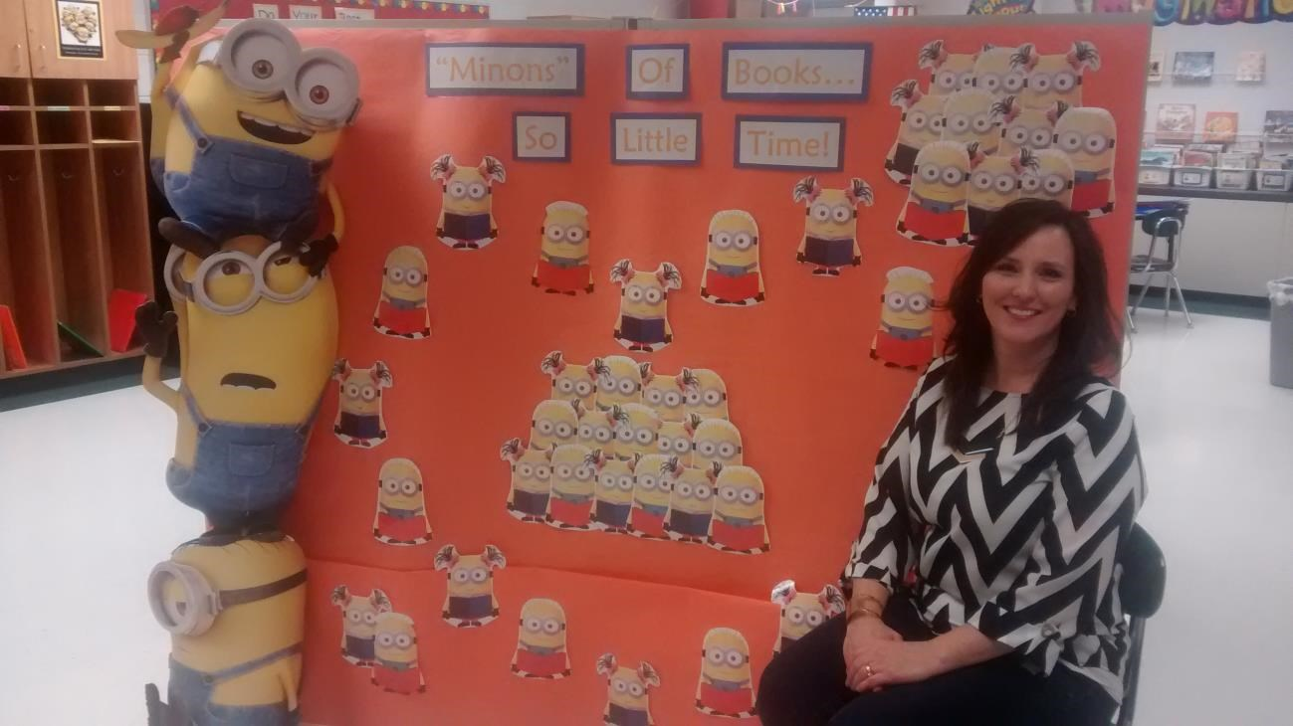

“Leaders Helping Readers” at Tri-County North Elementary: Check out the Lesson Plan that Cindy has shared. We really like the additional graphic organizer used with every new book. A KWL is used with a non-fiction book (What I “Know”-“Want to Know”-“Learned”). A “Making Predictions” is used with fiction books. You have many choices for graphic organizers on the www.readinga-z.com site. leaders-helping-readers-lesson-plan/

“Beyond the Bell/Generals Rockin for Readers” at Ridgewood Middle and Elementary: Thank you Christopher and Ryan for sharing these with us!
mentoring-program-enrollment-letter/

Toledo’s REACH Academy has 40 Fifth Graders mentoring 40 First Graders! What a joy it was to see this plan in action. reach-ideas-organization/

Toledo’s Sunbridge School: How fortunate to have dependable mentors from St. Johns Jesuit High School & Academy mentoring their students. Amanda shared her “Word Bank” motivator to build vocabulary.
“Mentors: If the student misses a word, please print it on a "word dollar" and place it in the Word Bank Envelope…” word-bank-vocabulary-help/

Upcoming M4RA Trainings in 2016: http://www.m4ra.org/instruction-sessions2015-2016/ Additional free trainings will be scheduled by request.

Best wishes for the close of 2015 and happy holidays to you and your families,

Debby & Amy
Debby Ambroza & Amy Freeman

Please reply to this email and type “Unsubscribe” in the Subject line if you would like to be removed from our database for future mailings. Please click “Forward” if you think this email might be useful to someone else.
Amy Freeman
Mentoring 4 Reading Achievement
Program Director amy.freeman@M4RA.org
1.844.220.1647 (toll free)
Ohio Coalition for the Education of Children with Disabilities

